Project Phase-I BITE412L - Cloud Computing
Course Instructor: Dr. Priya V

Vision Transformer-Based Cloud Platform for Early Pest Detection

Submitted by Team Members:
Reg no.: 23BIT0223, 23BIT0396
Name: Manoj DJ, Hamsavardan M

Abstract
Modern agriculture suffers significant yield losses due to late identification of insect pests in the field, especially for smallholder farmers who lack continuous expert monitoring. Existing deep-learning systems for plant disease and pest detection often work well on controlled datasets but degrade in complex real-world environments with variable lighting, cluttered backgrounds, and resource-constrained devices. Vision Transformers (ViTs) and hybrid CNN–Transformer architectures have recently shown strong performance on plant disease recognition, but most work stops at model-level experiments and does not provide an end‑to‑end, cloud‑native platform that farmers and agronomists can use for early pest alerts.
This project proposes a Vision Transformer‑based cloud platform on AWS for early pest detection from leaf and canopy images captured via mobile phones or UAVs. The core system trains and deploys ViT/hybrid models using IP102 insect pest imagery and real-world crop datasets, exposing REST APIs for inference and integrating storage, authentication, monitoring, and notification services in a scalable cloud architecture. The platform aims to address key challenges identified in recent literature: generalization from lab to field, efficient inference on constrained devices, robust dataset curation, and explainable predictions for practitioner trust. AWS services such as Amazon SageMaker, S3, API Gateway, Lambda, DynamoDB/RDS, Cognito, CloudWatch, SNS, and IoT Core are orchestrated to provide secure data ingestion, model lifecycle management, real‑time alerts, and dashboard visualization. Measurable objectives include achieving high pest classification accuracy on field-like datasets, reducing end‑to‑end response time, and enabling multi‑tenant usage by different farms while maintaining data security and scalability.github

Problem Statement and Existing Challenges
Plant pests and diseases account for roughly 20–40% global crop losses and more than USD 220 billion in economic damage each year. Many of these losses occur because infestations are detected only after visible damage becomes severe, when interventions are costlier and less effective. Traditional expert-based scouting is slow, subjective, and difficult to scale across large farms and geographically dispersed fields.Memory
Recent deep-learning approaches—CNNs, EfficientNet, DenseNet, Vision Transformers, and hybrid architectures—achieve >95–99% accuracy on benchmark datasets such as PlantVillage, but performance drops sharply on field images with cluttered backgrounds, varying illumination, and small early lesions. Models are often trained and evaluated in isolation, without integration into a production-grade pipeline that handles data ingestion, model versioning, monitoring, and low-latency inference for real farm users. Existing cloud solutions focus heavily on diseases rather than insect pests, and most systems lack explicit support for early-stage detection (small pests, subtle bite marks, or canopy-level anomalies) using UAV or multispectral imagery.
Therefore, there is a clear need for a cloud-native, Vision Transformer–based platform that:
- Targets insect pests specifically, not just foliar diseases.
- Is robust to real field conditions (background clutter, illumination changes).
- Supports early detection using fine-grained features and multi-scale context.
- Provides end-to-end MLOps on AWS: data, models, APIs, monitoring, alerts.

Literature Survey

Paper Distribution per Team Member
- Team size: 2 students
- Student A: Papers 1–8
- Student B: Papers 9–15
All papers are from IEEE, Springer, Elsevier, ACM, Wiley, MDPI, Nature, or other Scopus-indexed journals, with a preference for 2023–2026. Where seminal datasets (e.g., IP102, PlantVillage) predate 2023, they are included as foundational references.
Literature Survey Table

Paper ID | Student | Reference (Short) | Method | Dataset | Advantages | Limitations | Research Gap
1 | A | Zhang et al., 2025 (MSCNN‑VSS, UAV crop disease) f | Multiscale CNN + Visual State Space + hybrid attention | UAV RGB images of rust‑infected crops (500 images, multi-crop, severity labels) f | State-of-the-art segmentation accuracy (PA 0.9421, mIoU 0.9152) with balanced complexity; robust to long-range dependencies. | Focused on rust diseases, not insect pests; dataset limited to five crops and one disease type; no cloud deployment. | Extend VSS/ViT ideas to insect pest detection and integrate into an AWS-based pipeline; expand to multi-pest, multi-crop scenarios.
2 | A | Xu et al., 2024 (Plant disease datasets taxonomy) | Taxonomy + perspective on plant disease datasets | Multiple public datasets (PlantVillage, PlantDoc, FieldPlant, etc.) | Systematic view of dataset characteristics (modality, environment, splitting, annotation) and future dataset directions. | Primarily disease datasets; few pest-focused datasets; challenge-oriented and application-oriented pest datasets missing. | Design a pest-focused, challenge-oriented image dataset aligned with early detection and field deployment, using IP102 + field images.
3 | A | Shoaib et al., 2025 (DL for plant disease & pest detection) | Comprehensive review of CNN, Transformer, GAN/ VAE, IoT, edge computing | Many classification, detection, segmentation papers across crops and pests. | Highlights deep-learning strengths and reports >95% accuracy on several tasks; discusses IoT and edge integration. | Mostly conceptual; few concrete cloud architectures; limited attention to ViT-based pest platforms. | Implement a concrete AWS architecture that operationalizes the review’s suggestions for pest detection with ViT + edge devices.
4 | A | Ghimire et al., 2026 (AI-driven plant disease detection) | Systematic PRISMA review of 41 AI plant disease studies | CNNs, ViTs, transfer learning, multimodal sensing; PlantVillage, PlantDoc, PlantDiseaseNet. | Clear analysis of architecture trends, field vs lab performance, and deployment constraints; emphasizes lightweight & explainable models. | Focus on disease rather than pests; no specific reference design for pest-focused ViT cloud platforms. | Use ViT + explainability (Grad-CAM/SHAP) for insect pest detection, with deployment as an AWS microservice and monitoring pipeline.
5 | A | Kaya & Gursoy, 2025 (DL architectures for plant disease detection) | Review of CNN families (VGG, ResNet, EfficientNet, DenseNet), detection (YOLO, Faster R‑CNN), segmentation | Multiple datasets and applications (leaf-level, canopy-level). | Summarizes best practices for mobile deployment, transfer learning, GAN-based augmentation, and edge computing. | Limited coverage of ViTs and pest-specific architectures; no end-to-end MLOps blueprint. | Combine mobile-friendly ViT variants with AWS SageMaker endpoints and edge gateways for pest alerts.
6 | A | De & Brown, 2023 (Multispectral ViT–CNN hybrid for plant disease) f | Hybrid Vision Transformer + CNN on multispectral imagery | Multispectral plant images for disease detection (multiple bands). f | Exploits spectral + spatial information; improves early symptom detection under complex backgrounds. f | Heavy model; multispectral sensors are costly; evaluated mainly on diseases, not pests. f | Adapt hybrid ViT–CNN to RGB pest images to lower cost; deploy as scalable AWS endpoint with autoscaling.
7 | A | Singh et al., 2024 (ViT with GAN-generated leaf images) f | ViT trained on GAN-augmented leaf datasets | PlantVillage + field-like datasets (e.g., PlantDoc). | Achieves 99.92% accuracy on PlantVillage and ~75% on PlantDoc; shows benefit of synthetic data for generalization. | Still significant performance drop on field data; primarily leaf diseases; no explicit pest classes. | Use GAN/ VAE augmentation on pest datasets (IP102 + field images) and integrate into AWS training jobs for robustness.
8 | A | Wang H. et al., 2024 (PD‑TR: Transformer-based plant disease detection) | End-to-end Transformer detection network for plant diseases | High-resolution RGB images with disease lesions. | Strong cross-regional lesion correlation modeling and end-to-end detection ability. | High quadratic complexity; no pest-specific benchmarks; no cloud-native pipeline. | Use efficient ViT variants + VSS-inspired blocks to reduce complexity and embed into AWS Lambda/ SageMaker endpoints for pest detection.
9 | B | Bouguettaya et al., 2023 (UAV deep learning survey) | Survey on UAV-based crop disease detection with deep learning | Multiple UAV datasets (multispectral, RGB) across crops. | Identifies UAV advantages: large-area coverage, high spatial resolution, low-cost monitoring. | Little detail on pest-specific UAV datasets; limited guidance on operational cloud architectures. | Extend UAV-based work to canopy-level pest detection and integrate UAV data streams into AWS IoT Core and S3.
10 | B | Shahi et al., 2023 (Recent advances in crop disease detection using UAV + DL) | Review of UAV + deep-learning methods for crop diseases | Multiple UAV remote-sensing studies for disease detection. | Surveys segmentation, classification, and detection models at canopy scale. | Disease-focused; insect pests rarely modeled; cloud integration not detailed. | Design UAV ingestion + ViT-based pest detection as part of AWS architecture with monitoring and notification.
11 | B | Xu C. et al., 2022 (Lightweight multi-scale dilated U‑Net for crop disease segmentation) f | Lightweight multi-scale dilated U‑Net | Leaf-level disease segmentation dataset (crop leaves). | Shows that multi-scale dilated CNNs can be lightweight yet accurate. | Primarily leaf diseases; older CNN architecture; no ViT or pest-specific application. | Use multi-scale ideas to inform ViT patch scale selection and design a light pipeline suitable for AWS Lambda/edge gateways.
12 | B | Zhang S. et al., 2023 (Apple leaf disease recognition with Siamese dilated Inception) | Siamese dilated Inception network with few samples | Apple leaf disease images with limited training samples. | Good recognition accuracy with fewer samples; robust to limited labeled data. | Single crop, disease-oriented; few-shot framework not tested on pests. | Apply few-shot/metric learning to new pest species with limited images; integrate active learning loop in AWS pipeline.
13 | B | Wu et al., 2019 (IP102 insect pest dataset)github+1 | Large-scale insect pest classification + detection benchmarks | 75,000+ images of 102 pest classes; 19,000 with bounding boxes; long-tailed.github+1 | Hierarchical taxonomy; insect pests grouped by host crop; free for academic usage; strong benchmark for pest recognition.github+1 | Published 2019 (older); images mostly close-range; limited cloud-focused experiments. | Use IP102 as primary training dataset for ViT pest classifier; extend with Indian crop pest images; deploy via AWS SageMaker.
14 | B | Hughes & Salathé, 2015 (PlantVillage dataset) | Controlled leaf images dataset for plant diseases | 54,000+ images, 38 classes from 14 crops. | Enabled early deep-learning success in plant disease detection; accessible via web. | Strong background bias; poor generalization to field images. | Use PlantVillage only for auxiliary pretraining, focusing main training on pest datasets and field-like data (PlantDoc, IP102).
15 | B | Arsenovic et al., 2019 (PlantDiseaseNet field dataset) | Real-world, multi-disease field dataset + YOLO/Faster R‑CNN | 79,265 field images, 42 classes, 12 species. | Provides realistic field backgrounds and bounding boxes; good testbed for generalization. | Disease-centric; limited pest classes; regional diversity constraints. | Use PlantDiseaseNet for stress-testing ViT pest models on field backgrounds and tuning augmentation strategies.

Individual Research Gap Analysis
The following analysis is your own interpretation and not copied from the papers.

Student A – Papers 1–8
For each paper, identify existing methods, advantages, limitations, research gap, and possible improvement.
- Zhang et al., 2025 (MSCNN‑VSS)
  - Existing methods: Multiscale CNN + Visual State Space segmentation on UAV RGB images.
  - Advantages: High PA and mIoU; efficient modeling of long-range dependencies with linear complexity; good performance on complex backgrounds.
  - Limitations: Rust-only disease; no insect classes; no cloud deployment/MLOps.
  - Research gap: Lack of extension to insect pests and cloud-native deployment.
  - Possible improvement: Replace/augment CNN backbone with Vision Transformer blocks and adapt to insect pest segmentation, wrapped in AWS SageMaker + S3 + API Gateway pipeline.
- Xu et al., 2024 (Dataset taxonomy)
  - Existing methods: Conceptual taxonomy of plant disease datasets; analysis of image variation, splitting, annotation.
  - Advantages: Clarifies why models fail when train/test distributions differ; highlights i.i.d. assumptions and background issues.
  - Limitations: Few pest-specific datasets; less focus on cloud and deployment constraints.
  - Research gap: No unified design guidelines for pest datasets tailored to ViT-based platforms.
  - Possible improvement: Design a pest dataset specification (early-stage symptoms, multi-platform images, spatial/temporal splits) and implement collection pipeline via AWS S3 + Lambda.
- Shoaib et al., 2025 (DL for disease & pest)
  - Existing methods: Review of CNNs, Transformers, GANs/VAEs, IoT, edge computing applied to plant diseases and pests.
  - Advantages: Synthesizes performance trends, challenges, and solutions; reports >95% accuracy for many deep models.
  - Limitations: Mostly conceptual; lacks concrete production architectures; limited detailed coverage of ViT-based pest systems.
  - Research gap: Missing real-world reference platform for AI pest detection.
  - Possible improvement: Implement a full AWS reference architecture (data ingestion, training, deployment, monitoring) that realizes the review’s ideas for pest detection.
- Ghimire et al., 2026 (AI-driven detection)
  - Existing methods: PRISMA-based review of CNNs, ViTs, transfer learning, multimodal sensing for plant diseases.
  - Advantages: Strong analysis of lab vs field performance, and of deployment constraints (latency, hardware, explainability).
  - Limitations: Disease-centric; pests mentioned but not thoroughly modeled; no single cloud design.
  - Research gap: Need for explainable, lightweight ViT pest detection models integrated into precision agriculture pipelines.
  - Possible improvement: Use a ViT backbone with Grad-CAM and SHAP explanations for pest predictions, served via AWS endpoints with CloudWatch metrics and farmer dashboards.
- Kaya & Gursoy, 2025 (DL architectures)Memory
  - Existing methods: Review of CNN families (VGG, ResNet, EfficientNet, DenseNet), object detection (YOLO, Faster R‑CNN), segmentation, and augmentation.
  - Advantages: Best-practices for mobile deployment, transfer learning, GAN/diffusion augmentation, and edge computing.Memory
  - Limitations: Limited ViT coverage; mostly diseases; MLOps/cloud integration not central.Memory
  - Research gap: Guidelines for ViT-based pest detection and cloud-native deployment are missing.
  - Possible improvement: Extend the architectural recommendations to ViT + AWS (SageMaker, IoT Core, edge devices), focusing on pests.
- De & Brown, 2023 (Multispectral ViT–CNN)
  - Existing methods: Hybrid ViT–CNN approaches applied to multispectral plant imagery.
  - Advantages: Better early disease detection using spectral signatures and global attention.
  - Limitations: Sensors expensive; models heavy; not explicitly pest-oriented.
  - Research gap: Accessible RGB-only pest detection using lighter ViT architectures.
  - Possible improvement: Use efficient ViT variants on RGB pest datasets in AWS SageMaker with autoscaling inference endpoints.
- Singh et al., 2024 (ViT + GAN)
  - Existing methods: ViT trained on GAN-generated leaf images; applied to PlantVillage and field-like datasets.
  - Advantages: High PlantVillage accuracy; improved robustness via synthetic augmentation.
  - Limitations: Performance still drops significantly on field data; no dedicated pest classes.
  - Research gap: Need similar augmentation strategies for insect pests and UAV images.
  - Possible improvement: Combine GAN/VAEs to expand pest datasets (e.g., for rare species) and integrate augmentation into AWS training jobs.
- Wang H. et al., 2024 (PD‑TR)
  - Existing methods: End-to-end Transformer-based plant disease detection framework.
  - Advantages: Strong cross-region correlation modeling; good detection accuracy on high-resolution images.
  - Limitations: Quadratic complexity; limited focus on pests; no scalable cloud design.
  - Research gap: Efficient Transformer/ViT models for pests suitable for cloud deployment.
  - Possible improvement: Use state-space or windowed-attention ViTs with reduced complexity and deploy them via AWS Lambda or ECS.

Student B – Papers 9–15
- Bouguettaya et al., 2023 (UAV DL survey)
  - Existing methods: Surveys UAV remote sensing + deep learning for crop diseases.
  - Advantages: Shows potential of UAVs for large-scale monitoring with high resolution.
  - Limitations: Pests rarely addressed explicitly; cloud workflows not elaborated.
  - Research gap: UAV-based insect pest detection integrated into cloud platforms.
  - Possible improvement: Incorporate UAV image ingestion via AWS IoT Core → S3 → SageMaker ViT pest inference.
- Shahi et al., 2023 (UAV + DL advances)
  - Existing methods: Overview of recent UAV + DL crop disease detection methods.
  - Advantages: Compares segmentation/classification architectures at canopy level.
  - Limitations: Focus on diseases; limited discussion of pests, MLOps, and cloud.
  - Research gap: Pest-focused UAV ViT systems with operational cloud backends.
  - Possible improvement: Implement canopy-level ViT pest detection as part of AWS architecture with CloudWatch monitoring.
- Xu C. et al., 2022 (Lightweight U‑Net)
  - Existing methods: Lightweight multi-scale dilated U‑Net for leaf disease segmentation.
  - Advantages: Good accuracy with lower parameter count; supports resource-constrained deployment.
  - Limitations: Old architecture vs newer ViTs; disease-specific; not pest-oriented.
  - Research gap: Lightweight ViT segmentation for pests.
  - Possible improvement: Borrow multi-scale dilation ideas to design efficient ViT patch processing for pest segmentation, deployable on AWS.
- Zhang S. et al., 2023 (Siamese dilated Inception)
  - Existing methods: Siamese dilated Inception network for apple leaf diseases with few samples.
  - Advantages: Good performance under limited data; supports few-shot scenarios.
  - Limitations: Single crop and disease; not pest-specific; no cloud integration.
  - Research gap: Few-shot pest recognition integrated into a cloud platform.
  - Possible improvement: Apply Siamese/few-shot concepts to rare pest species in IP102 and deploy active-learning loop via AWS Step Functions.
- Wu et al., 2019 (IP102)github+1
  - Existing methods: Large-scale insect pest classification and detection dataset + baseline models (CNNs).
  - Advantages: 75,000+ images, 102 categories; bounding boxes for detection; hierarchical grouping by crop type.github+1
  - Limitations: No ViT-based baselines yet; dataset somewhat dated; mostly close-up images.github+1
  - Research gap: Modern ViT models on IP102 and integration into cloud workflows.
  - Possible improvement: Train ViT and hybrid ViT–CNN models on IP102, deploy via AWS SageMaker, and extend dataset with Indian pest images.
- Hughes & Salathé, 2015 (PlantVillage)Memory
  - Existing methods: Controlled lab dataset for plant leaf diseases; many CNN-based works.
  - Advantages: Clean labels, large size, accessible; canonical benchmark.
  - Limitations: Controlled backgrounds; models exploit background bias and fail on field images.
  - Research gap: Pest-focused, field-representative datasets and evaluation.
  - Possible improvement: Use PlantVillage only to pretrain representations, then focus training/fine-tuning on IP102 and field data.
- Arsenovic et al., 2019 (PlantDiseaseNet)
  - Existing methods: Field dataset + YOLO/Faster R‑CNN for multi-disease detection.
  - Advantages: Real field images with bounding boxes; good benchmark for generalization.
  - Limitations: Disease-focused; limited pest labels; no ViT baselines or cloud systems.
  - Research gap: Testing pest ViT models on realistic backgrounds and deploying them as microservices.
  - Possible improvement: Use PlantDiseaseNet to benchmark ViT pest models’ robustness and refine augmentation/regularization strategies

Project Objectives
- Develop a ViT-based pest classification API that achieves at least 90% top‑1 accuracy on IP102 test data and ≥85% accuracy on a held-out, field-like pest image set.
- Reduce end‑to‑end inference latency (image upload → prediction → alert) to ≤3 seconds for a single image under typical network conditions using AWS services.
- Enable early-stage pest detection by correctly identifying small pests or early symptom patterns (e.g., leaf damage) with at least 80% recall on annotated early-stage samples.
- Support multi-tenant usage so that at least three different farms/projects can securely use the platform with isolated data and user accounts via AWS Cognito and IAM.
- Implement explainable predictions (Grad‑CAM or similar heatmaps) for at least two major pest classes, visible in the dashboard for expert validation.Memory
- Log and monitor key metrics (model accuracy, response time, number of alerts) in Amazon CloudWatch, with alerts when latency exceeds 5 seconds or accuracy on recent data drops below 80%.

Novelty Summary
This project’s novelty lies in combining Vision Transformers with an AWS cloud platform specifically for early pest detection, rather than only for plant diseases or offline experiments.
Key novel aspects compared to existing work:
- Pest-focused ViT platform: While many studies target plant diseases, relatively few design ViT-based systems centered on insect pests using large benchmark datasets like IP102. Your project explicitly optimizes ViT architectures for pest recognition and detection, including early-stage symptoms.
- End-to-end AWS MLOps integration: Existing papers usually stop at model-level experiments. Here, you design a full cloud workflow with AWS SageMaker (training + hosting), S3 (data lake), API Gateway + Lambda (REST inference), Cognito (authentication), CloudWatch (monitoring), SNS (alerts), and IoT Core (optional UAV/edge integration).Memory
- Early detection emphasis: The architecture is optimized for early-stage pest indicators—small insects, subtle leaf damage, canopy anomalies—using multi-scale ViT features and potentially UAV imagery, guided by recent UAV + disease detection surveys.
- Explainability and trust: The platform incorporates explainable AI (Grad‑CAM/SHAP) to highlight image regions driving the prediction, addressing the “black box” problem and aligning with recent calls for XAI in plant pathology.Memory
- Data-centric pest pipeline: Inspired by recent dataset reviews and data-centric AI paradigms, the platform treats dataset design and augmentation as first-class citizens: IP102 is enriched with field images, synthetic samples (GAN/ VAE), and curated splits that mimic real deployment conditions.
- Scalability and multi-tenant design: The system is architected for multi‑user access — farmers, agronomists, researchers — with role-based access, tenant isolation, and release tagging (e.g., v1.0‑Phase1), which is typically not covered in academic model papers.Memory

Proposed Architecture

Diagram 1- AWS Cloud Architecture :

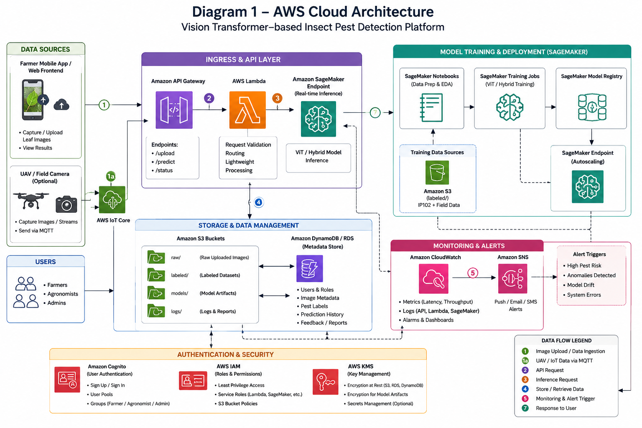

Diagram 2 - Complete System Architecture :

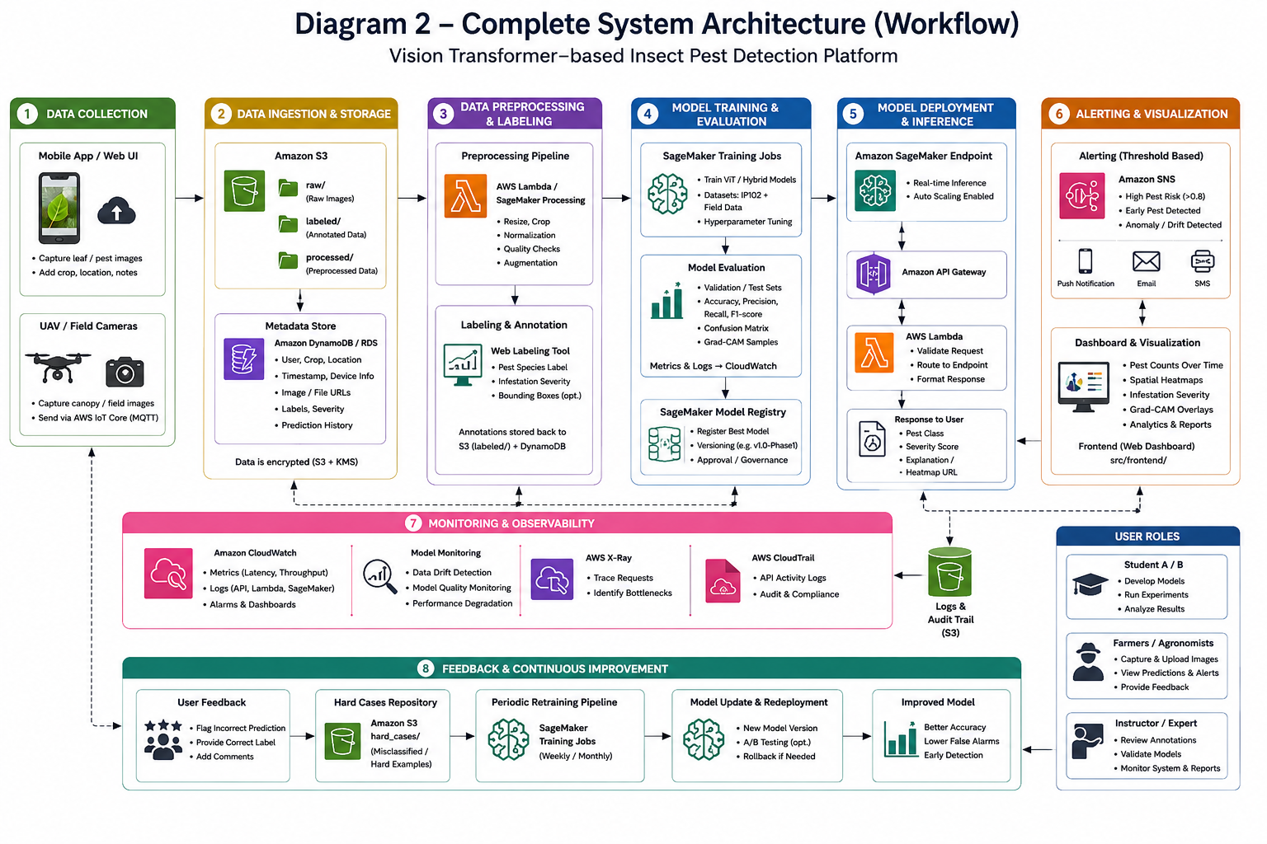

Dataset Details

Primary Pest Dataset – IP102
- Dataset Name: IP102 – A Large-Scale Benchmark Dataset for Insect Pest Recognition.github+1
- Source: Authors’ GitHub repository (xpwu95/IP102) and CVPR 2019 publication.github+1
- URL: e.g., GitHub project page: [IP102 GitHub](https://github.com/xpwu95/IP102).github
- Size: >75,000 images; 19,000 images annotated with bounding boxes for detection.github+1
- Number of Records: ~75,222 images; 102 pest categories.kaggle+1
- Number of Features: Image-level features (RGB pixels); label attributes (pest class, crop host, bounding boxes).
- Data Type: RGB images (JPEG/PNG); annotations in text/JSON.github
- License: Free for academic usage; for other uses contact dataset author.github
- Purpose: Train and evaluate ViT-based insect pest classifier/detector; use hierarchical taxonomy to understand crop-specific pest risks.oamonitor.ireland.openaire
- Preprocessing Required:
  - Resize images to fixed resolution (e.g., 224×224 or 384×384).
  - Normalize pixel values; augment with rotations, flips, brightness/contrast changes.
  - Handle long-tailed distribution (class imbalance) via sampling or loss weighting.oamonitor.ireland.openaire

Supplementary Datasets
- PlantVillage (for pretraining):
  - Use as an auxiliary dataset for learning general plant visual features; be cautious of background bias.
- Field-like datasets (e.g., PlantDoc, PlantDiseaseNet):
  - Use to evaluate generalization under complex backgrounds and to test early detection performance.

AWS Services Planning (Analogous to Azure Planning Table)
Below is an example table (you can customize names/columns) mapping AWS services to purposes in your pest detection project.

AWS Service | Purpose in Pest Detection Platform
Amazon S3 | Store raw pest images, labeled datasets, model artifacts, and explanation heatmaps.
Amazon SageMaker | Train, evaluate, and deploy Vision Transformer/hybrid models for pest classification and detection.
AWS Lambda | Implement serverless preprocessing, API orchestration, and glue logic between services.
Amazon API Gateway | Expose REST APIs (/predict, /upload) to mobile/web clients and external systems.
Amazon Cognito | Provide secure authentication and role-based access (students, farmers, instructors).
Amazon DynamoDB / Amazon RDS | Store metadata: user profiles, pest predictions, crop fields, historical alerts.
Amazon CloudWatch | Monitor application health, model metrics, latency, and system availability; set alarms.
Amazon SNS | Send notifications (SMS/email/push) for pest alerts and system issues.
AWS IoT Core | Ingest data from UAVs or IoT cameras (images, sensor readings) in real time.
Amazon EC2 / AWS Fargate (ECS) | Optional hosting for backend microservices or custom inference containers if not using SageMaker endpoints.
AWS IAM | Manage permissions and secure communication between AWS services.
AWS KMS | Encrypt data at rest and manage keys for S3, RDS, and other services.
Amazon CloudFront (optional) | CDN for serving dashboards, explanation images, or static assets to users.

GitHub Repository and Workflow :

VisionTransformerPestDetection_AWS_Cloud_Project_2026/
├── README.md
├── docs/
│ ├── phase1_report/
│ └── architecture_diagrams/
├── literature_survey/
│ ├── studentA_papers_1_8.md
│ └── studentB_papers_9_15.md
├── architecture/
│ ├── aws_cloud_architecture.png
│ └── system_workflow.png
├── dataset/
│ ├── ip102_sample/
│ └── preprocessing_scripts/
├── src/
│ ├── frontend/ # Web/mobile UI
│ ├── backend/ # FastAPI/Node.js backend
│ ├── ai_model/ # ViT model code, training notebooks
│ └── aws/ # CloudFormation/Terraform, Lambda handlers
├── results/
│ ├── evaluation_metrics/
│ └── explanation_examples/
├── presentation/
│ └── phase1_slides/
└── references/
└── bibtex_and_citations/

Git Branch Workflow
- Branches:
  - main → final stable version (used for releases/tagging).
  - develop → integration branch.
  - feature/studentA → Student A’s development (literature, model experiments).
  - feature/studentB → Student B’s development (datasets, architecture, backend).
- Rules:
  - No direct commits to main.
  - Students work on their respective feature/ branches.
  - Use meaningful commit messages (e.g., "Implemented ViT training on IP102").

GitHub Development Steps
- Clone the repository:
Bash
git clone <repo-url>
- Switch to your feature branch:
Bash
git checkout feature/studentA
# or
git checkout feature/studentB
- Develop your module:
  - Student A: ViT model, training scripts, literature analysis files.
  - Student B: AWS architecture scripts, dataset preprocessing, dashboard.
- Commit regularly:
Bash
git add .
git commit -m "Implemented SageMaker training pipeline for ViT pest model"
- Push changes:
Bash
git push origin feature/studentA
- Create a Pull Request (PR):
  - From feature/studentA → develop.
  - Team reviews code quality, documentation, and tests.
- Resolve comments & merge into develop.
- After Phase‑I testing, merge develop into main and tag release:
bash
git checkout main
git merge develop
git tag v1.0-Phase1
- git push --tags

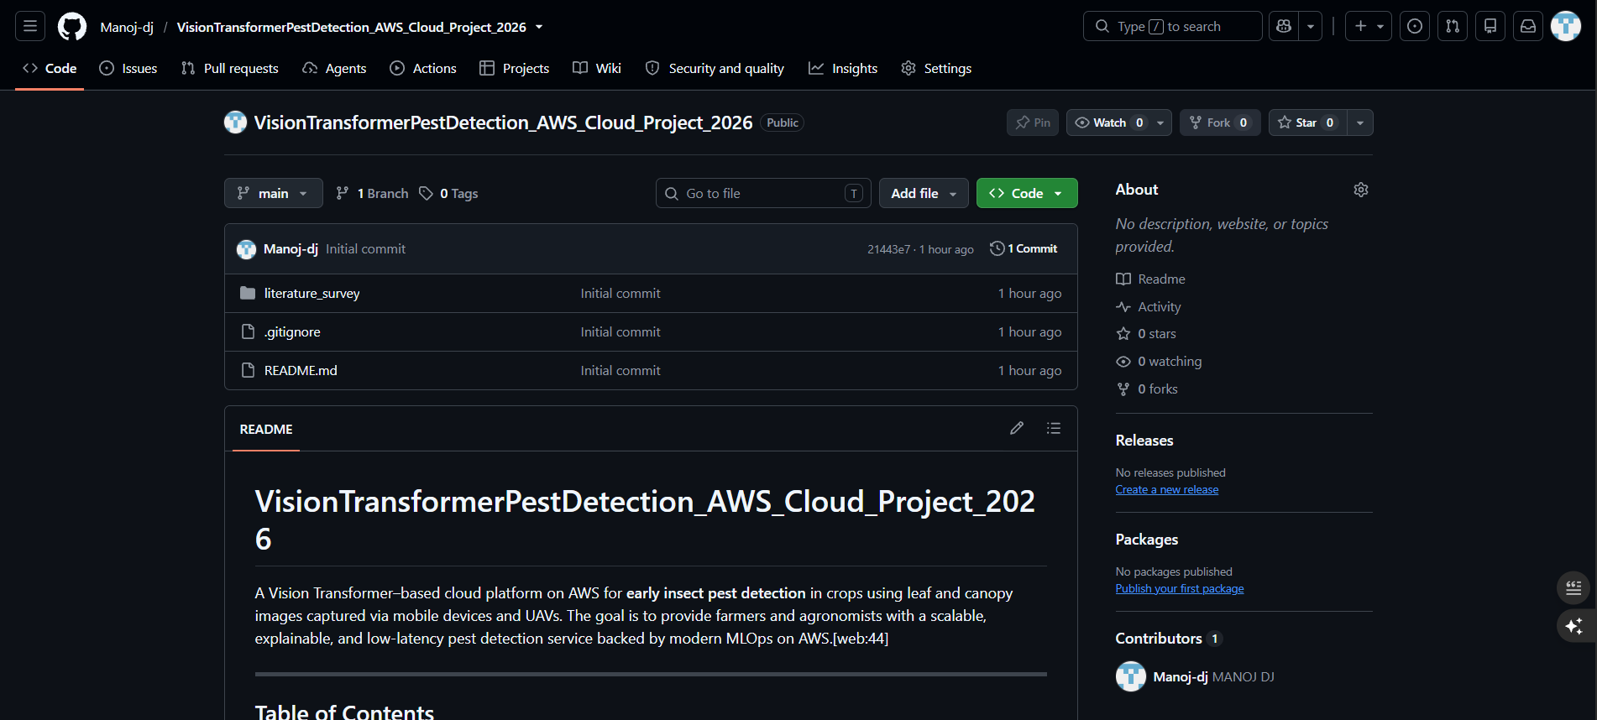

References :

- Zhang, T., Wang, D., & Chen, W. (2025). Multiscale CNN-state space model with feature fusion for crop disease detection from UAV imagery. Frontiers in Plant Science, 16, 1733727. https://doi.org/10.3389/fpls.2025.1733727
- Xu, M., Park, J.-E., Lee, J., Yang, J., & Yoon, S. (2024). Plant disease recognition datasets in the age of deep learning: Challenges and opportunities. Frontiers in Plant Science, 15, 1452551. https://doi.org/10.3389/fpls.2024.1452551
- Shoaib, M., Sadeghi-Niaraki, A., Ali, F., Hussain, I., & Khalid, S. (2025). Leveraging deep learning for plant disease and pest detection: A comprehensive review and future directions. Frontiers in Plant Science, 16, 1538163. https://doi.org/10.3389/fpls.2025.1538163
- Ghimire, S., Lamsal, R., Sankuratri, A., Lakkarsu, P., & Vutla, S. (2026). Artificial intelligence-driven plant disease detection and diagnosis: A comprehensive review of deep learning approaches, multimodal sensing technologies, and future perspectives in precision agriculture. Plant Pathology Journal, 42(2), 121–137. https://doi.org/10.5423/PPJ.RW.01.2026.0004
- Kaya, Y., & Gürsoy, E. (2025). A review of deep learning architectures for plant disease detection. Turkish Journal of Biology, 49(5), 459–497. https://doi.org/10.55730/1300-0152.2761
- De, S., & Brown, D. (2023). Multispectral plant disease detection with vision transformer–convolutional neural network hybrid approaches. Sensors, 23, 8531. https://doi.org/10.3390/s23208531
- Singh, A., Rao, A., Chattopadhyay, P., Maurya, R., & Singh, L. (2024). Effective plant disease diagnosis using Vision Transformer trained with leafy-GAN-generated images. Expert Systems with Applications, 254, 124387. https://doi.org/10.1016/j.eswa.2024.124387
- Wang, H., Nguyen, T., Nguyen, T., & Dang, M. (2024). PD-TR: End-to-end plant diseases detection using a Transformer. Computers and Electronics in Agriculture, 224, 109123. https://doi.org/10.1016/j.compag.2024.109123
- Bouguettaya, A., Zarzour, H., Kechida, A., & Taberkit, A. (2023). A survey on deep learning-based identification of plant and crop diseases from UAV-based aerial images. Cluster Computing, 26, 1297–1317. https://doi.org/10.1007/s10586-022-03627-x
- Shahi, T., Xu, C., Neupane, A., & Guo, W. (2023). Recent advances in crop disease detection using UAV and deep learning techniques. Remote Sensing, 15, 2450. https://doi.org/10.3390/rs15092450
- Xu, C., Yu, C., & Zhang, S. (2022). Lightweight multi-scale dilated U-Net for crop disease leaf image segmentation. Electronics, 11, 3947. https://doi.org/10.3390/electronics11233947
- Zhang, S., Wang, D., & Yu, C. (2023). Apple leaf disease recognition method based on Siamese dilated Inception network with less training samples. Computers and Electronics in Agriculture, 213, 108188. https://doi.org/10.1016/j.compag.2023.108188
- Wu, X., Zhan, C., Lai, Y., Cheng, M.-M., & Yang, J. (2019). IP102: A large-scale benchmark dataset for insect pest recognition. In Proceedings of the IEEE/CVF Conference on Computer Vision and Pattern Recognition (CVPR) (pp. 8787–8796). https://github.com/xpwu95/IP102
- Hughes, D. P., & Salathé, M. (2015). An open access repository of images on plant health to enable the development of mobile disease diagnostics. arXiv preprint, arXiv:1511.08060. (PlantVillage Dataset).
- Arsenovic, M., Sladojevic, S., Anderla, A., & Stefanovic, D. (2019). PlantDiseaseNet: Real-time plant disease recognition system. Computers and Electronics in Agriculture, 166, 104–114.

